**NOVEMBER 27, 2019**

**TO:** PRIESTS

**FR:** COORDINATOR OF FAMILY & LIFE PROGRAMS

**RE: SPONSOR COUPLE 2019 ADDITION: JOY FILLED MARRIAGE**

**CC:** DEACONS, SPONSOR COUPLES

**WHO:** Priests, Deacons, Family Life Coordinators, Sponsor Couples, Parish Level Marriage Preparation

**WHAT:** The Diocese of Evansville is adding “Joy Filled Marriage” (Ascension Press) to its parish level sponsor couple program offerings.

* Currently, the diocese uses the **For Better Forever** program for its parish level sponsor couple marriage preparation. This resource has been used for some time and was first created around 1979 (hard to believe that was almost 40 years ago).
* The Joy Filled Marriage program will provide an updated alternative program for parishes to utilize.
* The Joy Filled Marriage program is currently used by many other dioceses in the country.
* The JOY FILLED MARRIAGE program can be used as parishes see fit. Parishes can continue to use For Better Forever by itself. They can use FOR BETTER FOREVER and JOY FILLED MARRIAGE together or can switch solely to JOY FILLED MARRIAGE.

**WHEN:** The Joy Filled Marriage program can be utilized as soon as parish leaders, priests, sponsor couples, etc. have been trained.

**WHERE:** Joy Filled Marriage and For Better Forever are parish based sponsor couple programs. The diocese will continue to provide three UNVEILED retreats per year at SARTO.

**WHY:** Program Update

* The JOY FILLED MARRIAGE program updates teaching modalities (DVDS and online resources) while maintaining the integrity of traditional activities such as couple journaling and topic discussion.
* The JOY FILLED MARRIAGE provides a more Catholic response to various topics.

**HOW:** Next Steps

1. Parish Pastor decides if he wants to add JOY FILLED MARRIAGE to his parish marriage prep.
2. If yes, then parish staff and sponsor couples are trained. I will send out 2019 training dates soon.
3. Parishes can also set up individual trainings for their parishes by contacting me.
4. Parishes that are trained will then be able to order the JOY FILLED MARRIAGE resources just as they order the For Better Forever materials.

**ADDITIONAL INFORMATION:**

1. The time expenditure for Joy Filled Marriage is comparable to For Better Forever with an extra 1-2 sessions depending on how it is planned.
2. Monetary expense for Joy Filled Marriage is higher than For Better Forever (see below) due to additional resources included.
3. I am happy to meet and review the Joy Filled Marriage program with parish staff.
4. Parish staff can go to: <https://shop.ascensionpress.com/collections/joy-filled-marriage>  to review.
5. I am happy to answer questions by phone, email or in person.
6. Below is information regarding $$ expenditures for the Joy Filled Marriage program and what you get for the $$.

**PRICE COMPARISON FOR JOY FILLED MARRIAGE IN THREE DIFFERENT SCENARIOS**





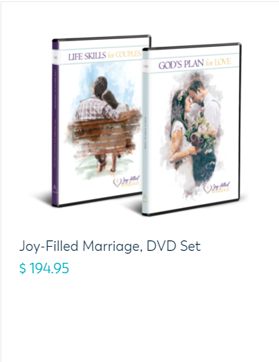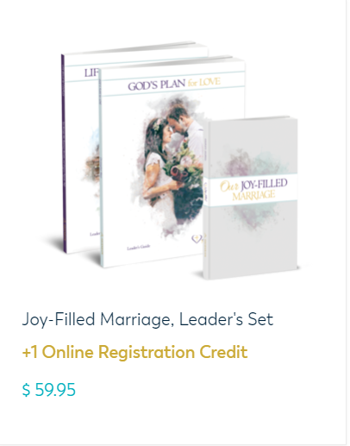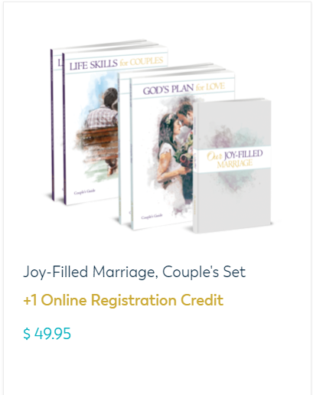**VISUALS OF JOY FILLED MARRIAGE PACKAGES**